**Tutorial #2**

***Structural analysis of advanced tailorable composite laminates (Abaqus)***

February 2024

Bangde Liu & Xin Liu



C:\Users\kotharit2\AppData\Local\Microsoft\Windows\INetCache\Content.MSO\D150AE7A.tmp

### Problem Statement

We study a clamped six-layer panel subjected to a uniform force on the left and right edge (*p* = 1 N/mm) as shown in Fig. 1. The layer thickness is 0.127 mm each and the lamina properties are E1 = 37e3 MPa, E2 = E3 = 9e3 MPa, G12 = G13 = 4e3 MPa, G23 = 4e3 MPa, nu12 = nu13 = nu23 = 0.28.

400 mm

400 mm

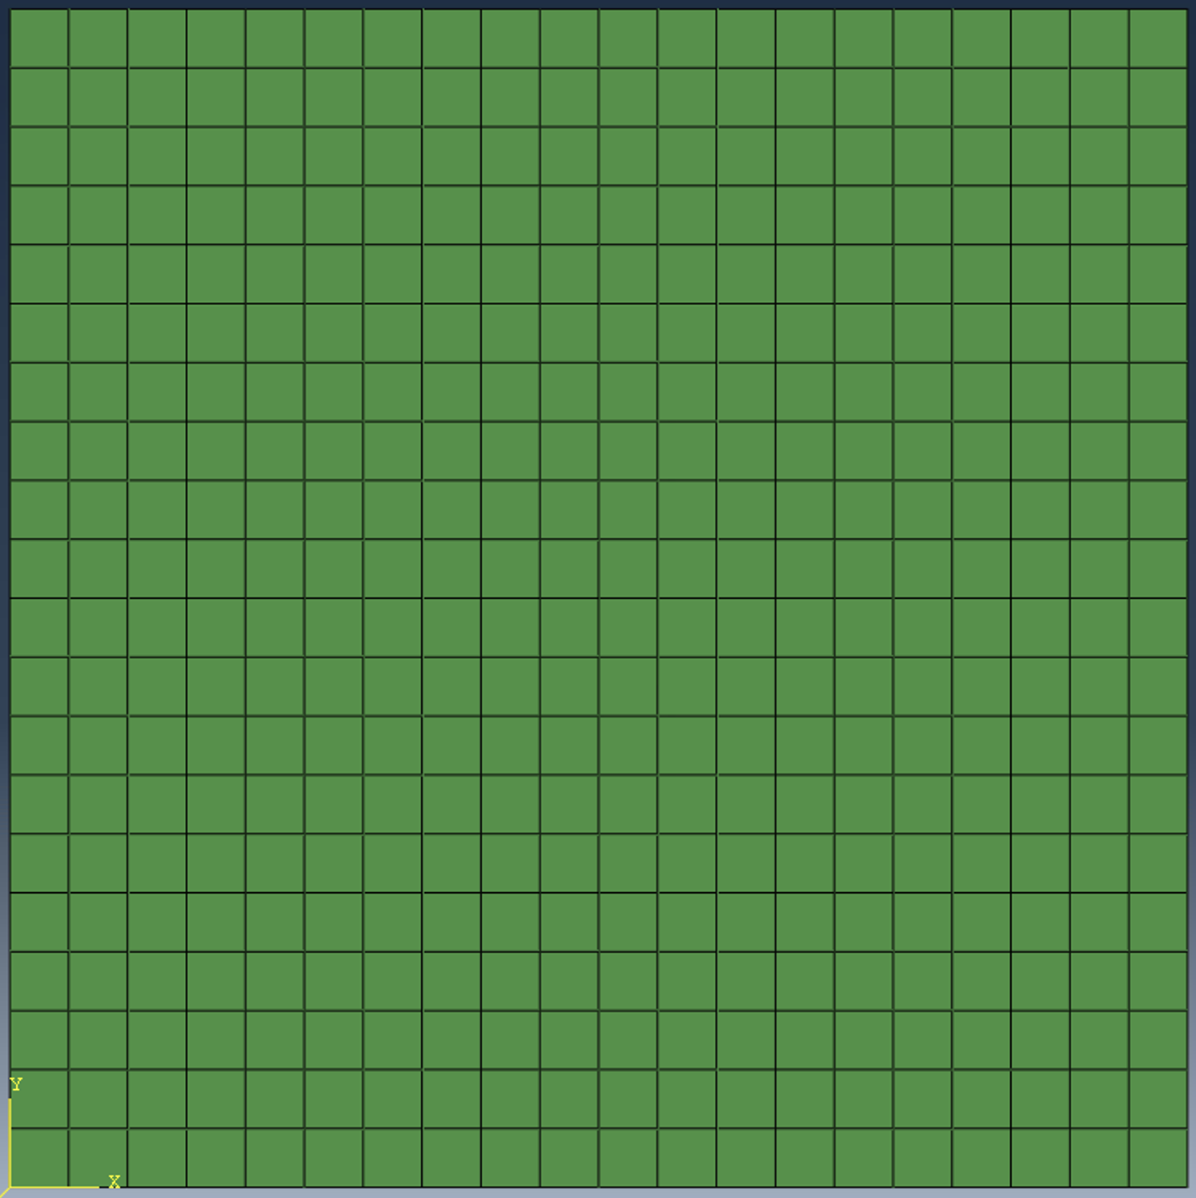

b

h

*x*

y

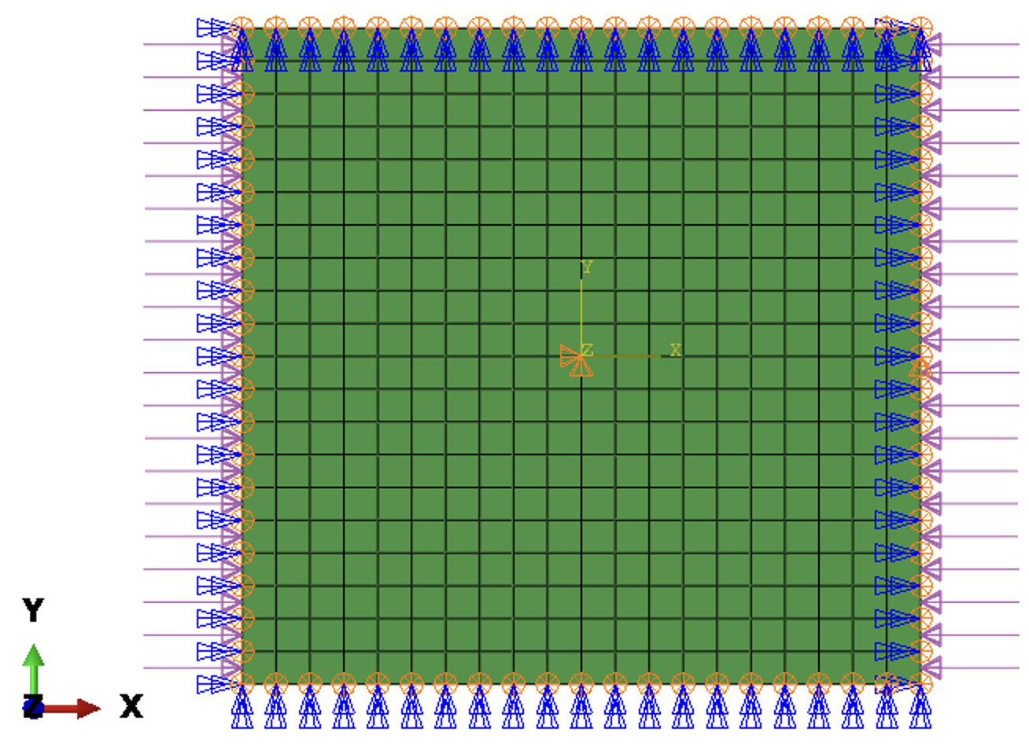

(a) Boundary conditions and loading conditions (b) Dimensions of the plate

Fig. 1 Plate

The laminate has six layers and fiber angles:

1st layer: $0^{∘}$

2nd layer: $θ\left(x\right)=2\left(v_{2}-v_{1}\right)\left|\frac{x}{B}\right|+v_{1}$

3rd layer: ${90}^{∘}$

where B is the width of the plate and equal to 400 mm in this example. The $v_{1}$ and $v_{2}$ are usually the design parameters to be optimized. In this example, we structural analysis and assume $v_{1}$ =20 and $v_{2}$ =80. The fiber path of the first layer of advanced tailorable composite laminate is plotted in Fig. 2.

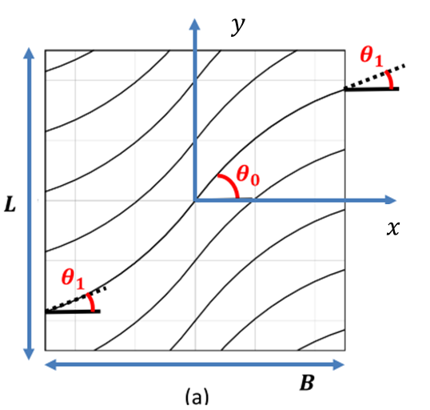

Fig. 2 Fiber Path of the first layer

### Open the CAE model and set current working directory

* Open the CAE model in the path “Plate/CAE model/plate400.cae”.

Fig. 3 Open CAE model

* Set the working directory to “Plate/SA” folder.

Fig. 4 Set work directory

### Define Fiber angles

* Plug-ins >ATC> Define fiber angles. Go to Plug-ins in Abaqus CAE. Click on ATC, and then on Define fiber angles.

Fig. 5 ATC Plug-in

* Define composite lamina with fiber orientation using one-line expression. Layer 1 entries for this example are as in Fig. 6. Layer 2 entries are as shown in Fig. 7. Layer 3 entries are as shown in Fig. 8.

Fig. 6 Layer 1

Fig. 7 Layer 2

Fig. 8 Layer 3

* Define a composite laminate. Click the “Layup” Button. Use the Layup text field in this window to specify layup. Brackets ‘[‘and ‘]’ are a must here and ‘s’ stands for symmetry.

Fig. 9 Layup

* Click the “Define” Button to assign values to design variables. Initial values for fiber angle variables are as specified in Fig. 10.

Fig. 10 Defined Variables

* Click Done on Define fiber angles dialog box to close the window. Note that this step must be completed so that the code will store all the design setups of the laminate.

### Structural Analysis

* Plug-ins >ATC> Structural analysis

Fig. 11 Structural Analysis Plug-in

* Select the name of the created job .inp file from the working directory\ and click Done.

Fig. 12 Select. inp jobfile

* The Structural Analysis is run in the command prompt window, as in Fig. 11.

Fig. 13 Run

* When completed, the post-processing can be carried out by opening .obd file from the “evals/eval.1” which is generated in the working directory.

Fig. 14 Result files

Fig. 15 Result